CMPG325
LB Madikwe
33167044
MILESTONE 1
Client Design Review

1. Client Requirements
1.1 Client Information
Item | Details
Organisation | Dijo Tsa Rona Foods Processing (Vryburg)
Client ID | CLI-032
Industry | Manufacturing
Project ID | CMPG325-2026-032
Addressing block | 192.168.25.0/24
Main Challenge | IPv4 VLSM subnetting
Wireless requirement | Wireless only in public areas
Change request | CR15 – second internet connection

1.2 Network requirements
The client needs a network that can support the different areas of the food processing organisation.
The network must:
- Connect the office users.
- Connect the production area.
- Provide access to servers.
- Provide a management network for network devices.
- Provide wireless access in the allowed public areas.
- Allow communication between the required networks.
- Use the assigned 192.168.25.0/24 address block.
- Use VLSM to avoid wasting IP addresses.
- Have two internet connections for better reliability.
- Be designed and tested in Cisco Packet Tracer.
- Allow the network to continue using the second internet connection if the main internet connection fails.

1.3 Wireless requirement
Wireless will not be provided across the whole factory.
It will only be available in the specified public areas. This helps to keep the wireless network limited to areas where it is required.
For the design, I have planned a separate Public Wi-Fi network.

1.4 Change request – CR15
The client requested a second internet connection.
The reason for this is resilience.
The network will have:
- ISP 1 – main internet connection
- ISP 2 – backup internet connection
- The second connection will be available if the first internet connection has a problem.

2. Physical Topology
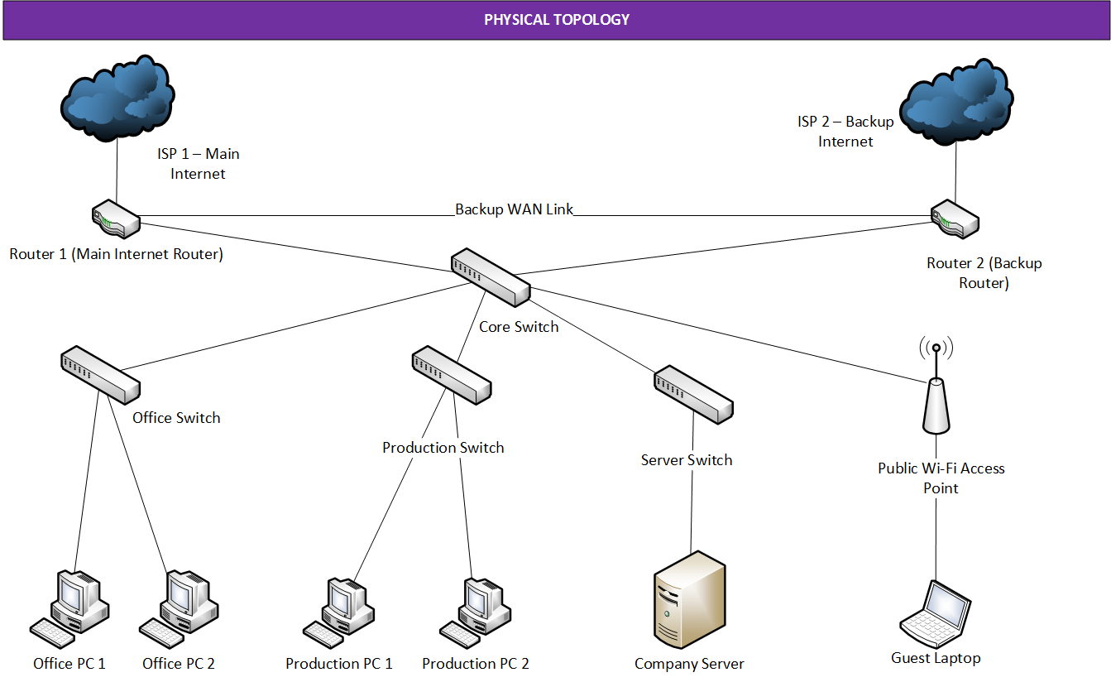
The physical topology shows the connection of the network devices. The core switch connects the different departments, while the two internet connections provide reliability through backup connection.

3. Logical Topology
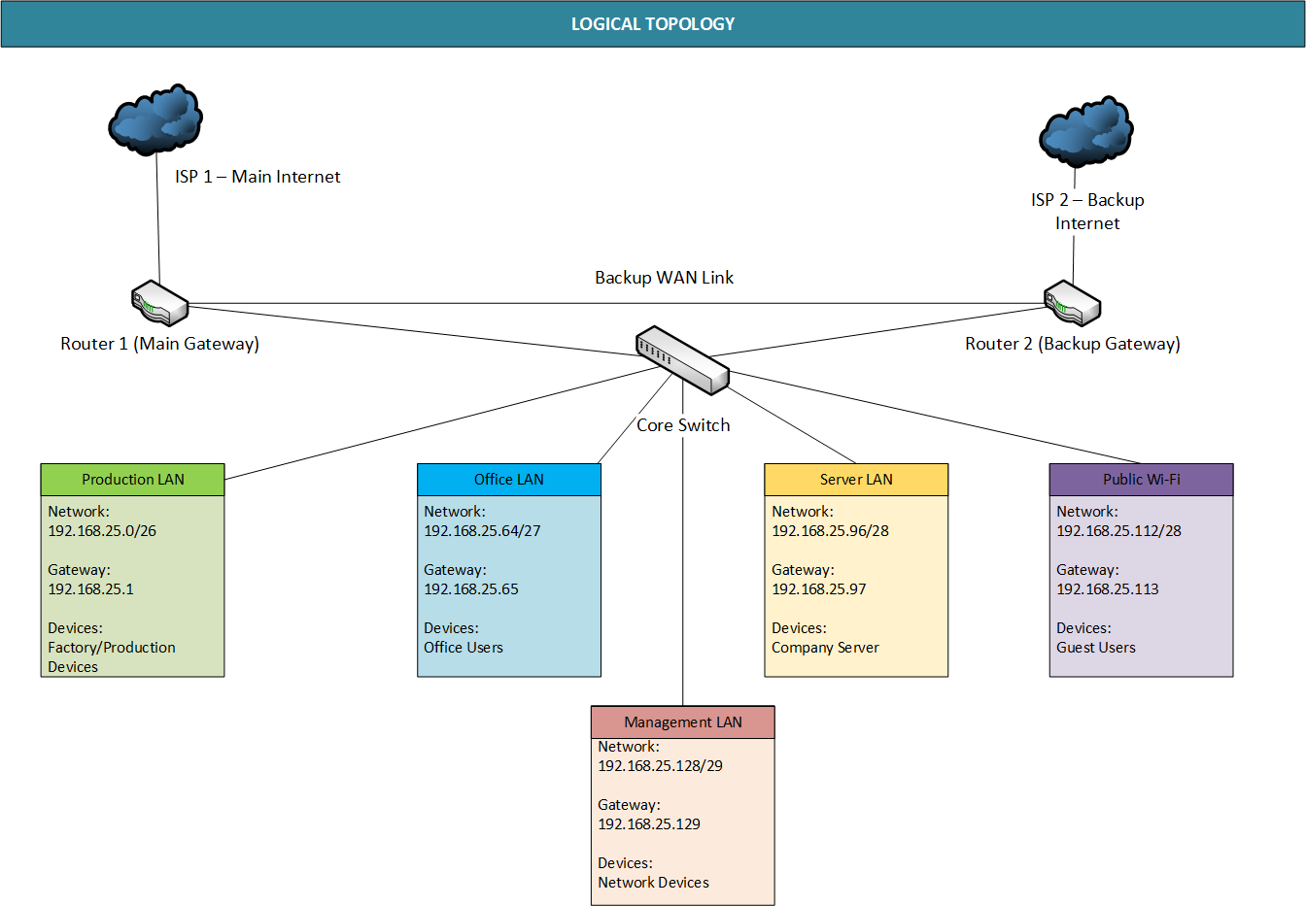

The logical topology separates the network into different VLANs using VLSM addressing. Each department has its own subnet to improve organisation and network management.

4. IP Addressing Plan
Network/  Department | Network Address | Prefix | Subnet Mask | Usable IP Range | Default Gateway
Production Network | 192.168.25.0 | /26 | 255.255.255.192 | 192.168.25.1  -  192.168.25.62 | 192.168.25.1
Office Network | 192.168.25.64 | /27 | 255.255.255.224 | 192.168.25.65  -  192.168.25.94 | 192.168.25.65
Server Network | 192.168.25.96 | /28 | 255.255.255.240 | 192.168.25.97  - 192.168.25.110 | 192.168.25.97
Public Wi-Fi Network | 192.168.25.112 | /28 | 255.255.255.240 | 192.168.25.113  - 192.168.25.126 | 192.168.25.113
Management Network | 192.168.25.128 | /29 | 255.255.255.248 | 192.168.25.129  -  192.168.25.134 | 192.168.25.129
Router-to-Router Link | 192.168.25.136 | /30 | 255.255.255.252 | 192.168.25.137  - 192.168.25.138 | N/A

Github Link: https://github.com/lizziebusisiwe0410/CMPG325-Network-Design-Project

